**Temperature responses of spear growth of continuously growing asparagus in Peru**

**Angela and Alan**

**IBERS**

**Introduction**

As part of an exercise to model the growth of asparagus in Peru in relation to remote sensing an important aspect is to develop a practical method of estimating spear growth as this is the commercial yield. This will allow estimation of the potential harvest and allow calculation of the amount of carbohydrate remaining in the root after harvesting. This is important as the carbohydrate stored in the roots is the energy source for the initially heterotrophic growth of the shoots on that form the canopy on which the future productivity of this perennial crop depends. The production of spears is usually described as a temperature dependant process responding to thermal time accumulated above a threshold and depending on spear length (Wilson, 1999; Graefe et. al., 2010). However, the temperature responses of spear growth referred to above have been developed for winter dormant asparagus. When it is grown in Peru the irrigated crop has is no winter dormancy and temperatures are usually above the thresholds of thermal time used for the winter dormant crop. Thus, these relationships need to be reconsidered for modelling spear growth in Peru. Here we describe an approach to this problem using field data as the controlled environment facilities required to develop the relationships used for temperate crops were not available. The aim was to develop practical relationships describing the effects of temperature on spear growth that can be used to estimate potential spear growth from average temperatures over recent years, particularly in regions like Peru with relatively low climate variability. These will then be used as a component of a crop model linked to remote sensing.

**Materials and Methods**

**Site, and Plant Material**

Measurements were made at a commercial farm operated by Danper in northern coastal Peru on irrigated crops of *Asparagus officinalis* L. variety UC157. A single harvest area was used for each of the Summer and winter measurements.

**Data collection:** As spear growth was very fast in Peru Data was collected for spear extension growth against time at approximately 2 h intervals during working hours. Data was collected in winter and summer over successive “cuts” during harvest . Measurements were started on ten spears (a “cut”) when their length was about 1-3 cm by fixing a ruler alongside each spear inside a transparent tube taking 15 minutes for each set of measurements. The measurements continued over 3-4 days for each group, by which time spears were over the usual maximum commercial harvest lengths. There were two periods of measurement: summer (November-December 2019, six cuts, daily measurements) and winter (May 2020, five cuts, daily measurements except Sundays). Air temperatures were also logged for each site at 15 (2019) or 30 (2020) minute intervals (where were temperature records collected?).

**Data curation of spear measurements and their timing.** Initially data for each cut was plotted as an approximate time course, and inconsistent values were removed and mean lengths of the spears were calculated for each measurement time. Records were available of the time at which each measurement was made and this was averaged for each group of measurements on ten spears.

**Results**

**Data processing of Temperature measurements.** Initial study of the time course of temperatures in relation to spear measurements (Fig 1.) showed that some measurements were made in periods of stable temperatures whilst some were collected during periods of falling and/or rising temperatures.



Fig 1. Time course of temperatures recorded during the growth of Cut 0 showing temperatures at time of first (●) and subsequent (**○**)measurements.

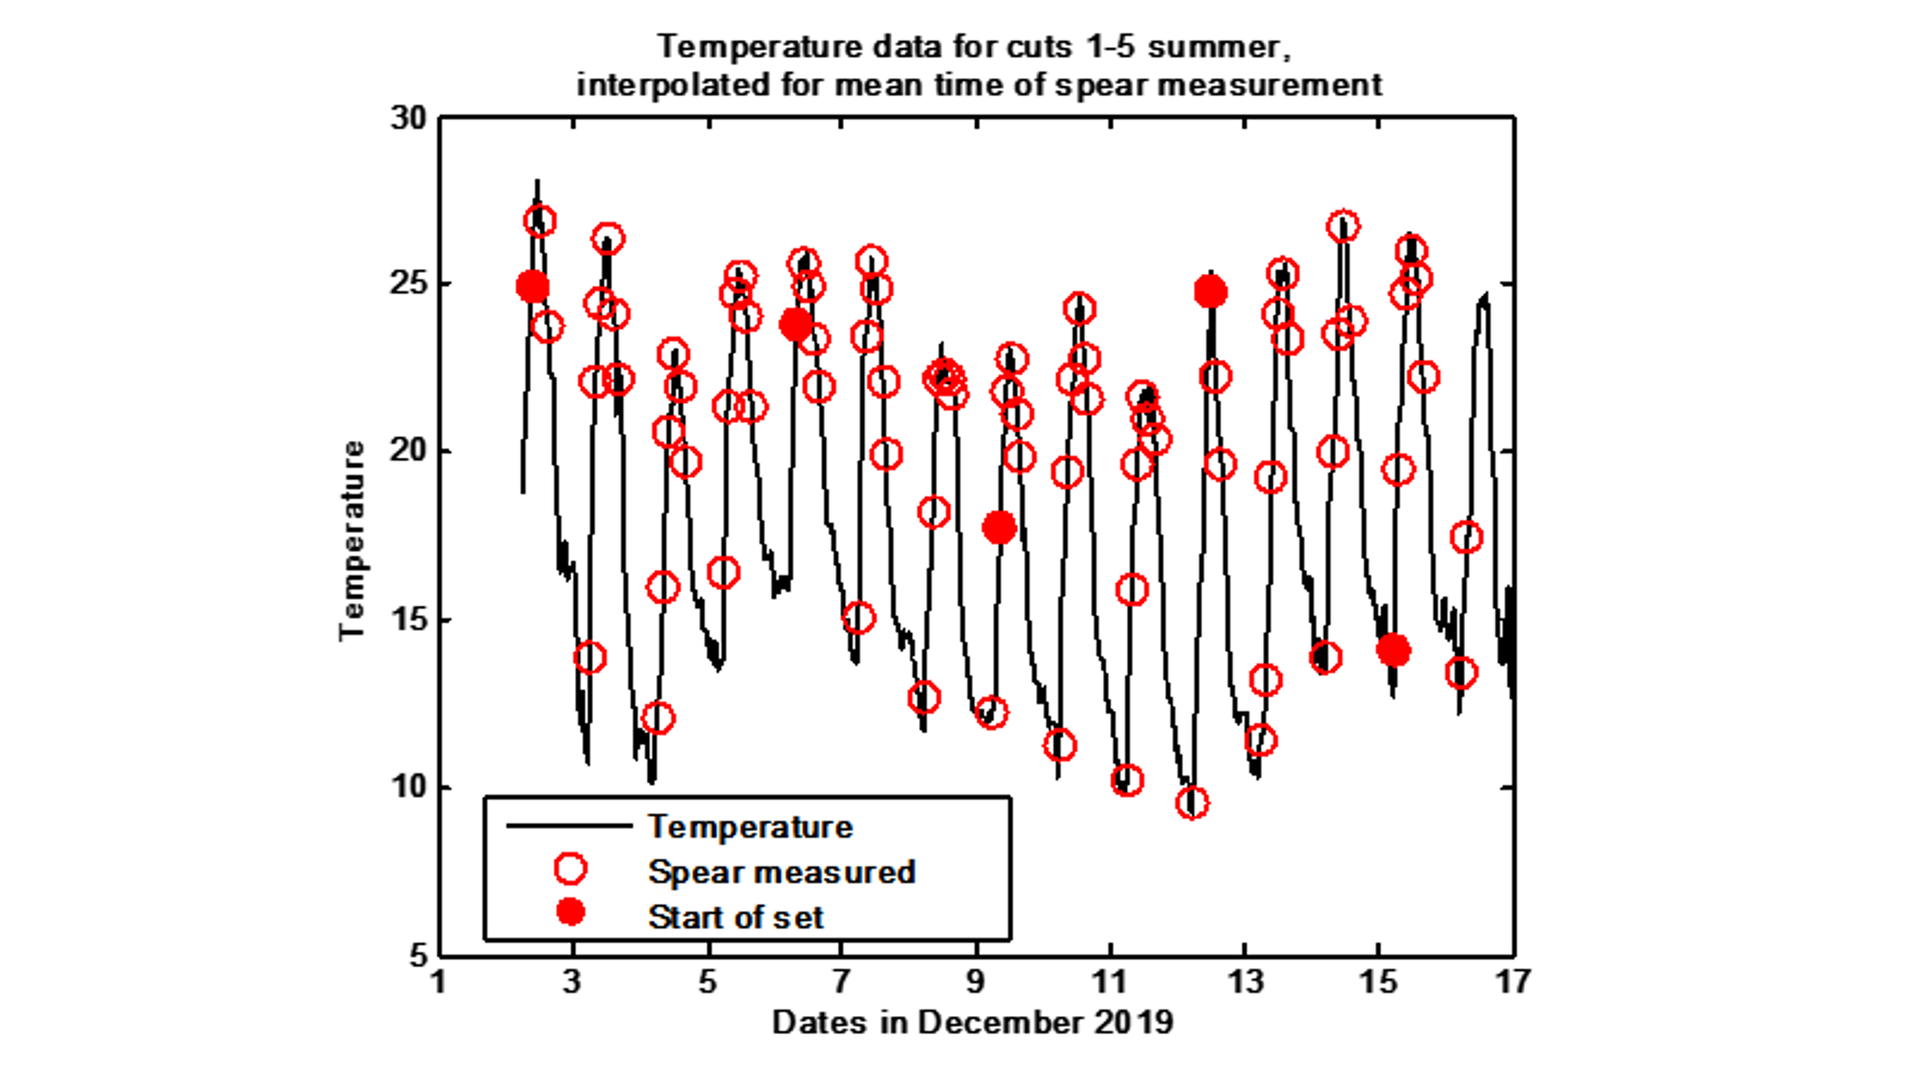

Fig 2. As fig 1 for five successive summer cuts with first measurement of each (●) shown

This observation of temperature variability of temperature profiles between sequential measurements was repeated for all summer (Fig 2) and winter measurements ( Fig 3).

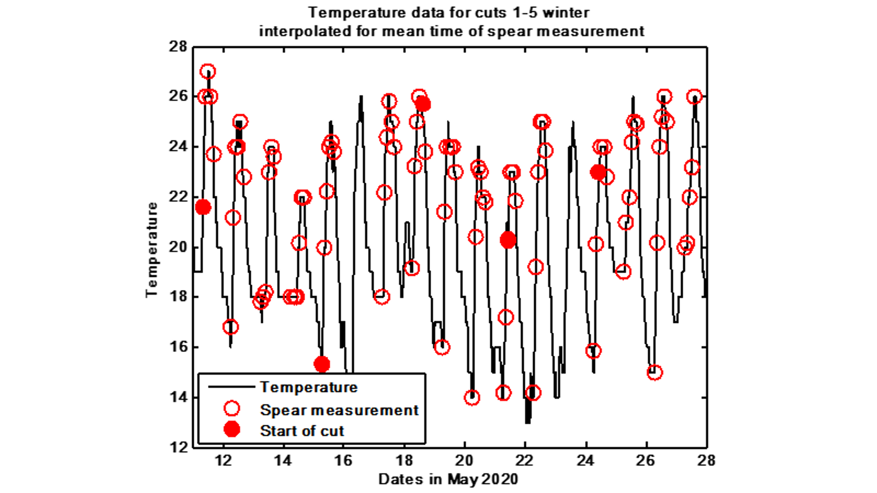

Fig 3. As fig 2 for winter cuts.

Thus it was decided to use a Taylor series integration method to asses the thermal time attributed to each growth measurement interval (Fig. 4). This integration was in units of C days for base temperatures of 0, 5, 7, 9 and 11 C as previous controlled environment experiments (Wilson, 20098; Graefe et al 2010) have suggested various base temperatures for thermal time accumulation in asparagus.



Fig 4 Method of Integration of thermal time illustrated for an 11 C thermal time base.

**Relating spear growth to thermal time.** Initially approaches based on relating relative growth rate between measurement intervals, temperature and spear length were tried (after Graefe et. al. 2010.). However, these did not work well for our data possibly because of the fluctuating temperatures well above the usual range of the base of thermal time in asparagus. However, it was observed that when plotted against accumulated thermal time, the curve of spear length with time was approximately exponential (Fig. 5).



Fig 5. Plots of spear lengths against accumulated thermal time above 0 C for six summer cuts symbols as shown in the legend

The various cuts followed parallel courses with the displacement largely due to the slightly different spear lengths at the start of measurements on each cut at a thermal time sum of zero. An exponential curve was fitted to the data for each cut:

eq(1)

y is spear length, cm, x is accumulated thermal time in C days, and A, B and R are the parameters controlling the shape of the curve.

Accumulated thermal time at a standard spear length was calculated from the fitted curve for each cut. In our data 7.39 cm was used as the standard length as it was within the data range for all cuts, and was not too small where measurements were less precise. The accumulated thermal time for 7.39 cm spear length was then averaged across all cuts, and the difference between the average and the value for each individual cut then used to align the thermal time bases between individual cuts. This then resulted in data that could be fitted by a single exponential line across all cuts. (Fig 6).



Fig 6. Plot of spear length against corrected accumulated thermal time with single exponential relationship fitted to all data, standard error of regression (S) 0.79 cm

For modelling purposes it is convenient to start each successive spear growing at a nominal length of 1cm and an accumulated thermal time of 0 C days. Thus the thermal time corresponding to 1 cm was calculated using the relationship above (see enlarged section of plot in Fig 7).



Fig 7. Enlarged section of Fig. 6 showing 1 cm point (+) used for adjusting relation to 1 cm and O Cd start.

This was used to modify the thermal time base further and refit a final equation that could be used to relate spear growth to accumulated thermal time from initiation at 1 cm and 0 C days (Fig. 8).



Fig 8. Final fitted relationship between modified accumulated thermal time above 0 C and spear length including the 0 C days and 1 cm point, S=0.79 cm.

The same process used with base temperatures for thermal time between 5 and 11 C appeared to work similarly (figs 9-11).



Fig 9 As Fig 8 but base temperature for thermal time accumulation 5 C, S=0.92 cm.



Fig 10. As Fig 8 but base temperature for thermal time accumulation7 C, S=1.01 cm.



Fig 11. As Fig 8 but base temperature for thermal time accumulation 9 C, S=1.14cm.



Fig 12. As Fig 8 but base temperature for thermal time accumulation11 C, S=1.36 cm.

**Conclusions**

This process has resulted in a practical method of estimating spear growth from accumulated thermal time for asparagus from the starting point of 1 cm and 0 C days thermal time. This starting point was used as it was a convenient reference for commencement of the modelling of spear growth once inhibition of spear growth was released, below ground processes have been completed and the spear had reached 1cm above ground. The process appears to work similarly for the base temperatures checked, with different parameters for the exponential equation used. This may be related to the relatively high temperatures compared with spring harvested winter dormant asparagus where a base temperature of 7.1 C for thermal time calculations for asparagus has been calculated (Wilson et al. 1999). However as the average standard error of the estimated spear length (s) was lower for 0 C it seems preferable to use 0 C as the base of thermal time for these calculations for the continuously active crops of asparagus studied here.

*And I should check out if the winter crops fit as well!*

**References**

Graefe, J., Heissner, A., Feller, C. Paschold, P-J, Fink, M. and Schreiner, M. (2010). A process oriented and stochastic simulation model for asparagus spear growth and yield. European Journal of Agronomy, 32, 195-204.

Wilson, D.R., Cloughley, C.G., Sinton, S.M. (1999) Model of the influence of temperature on the elongation rate of asparagus spears. Acta Horticulturae, 479, 297-304